How to connect labs to your iTero™ scanner through the MyiTero™ portal
- Go to myitero.com on any computer and log in using your username and password.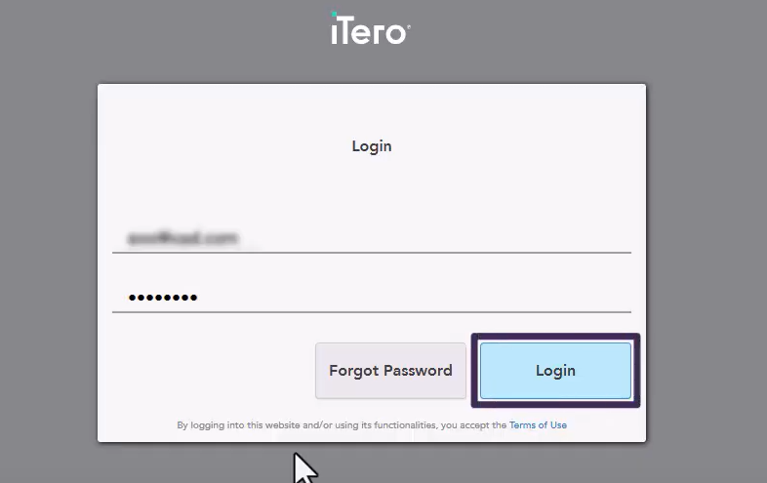
- On the home screen, click Settings, then select Practice Settings.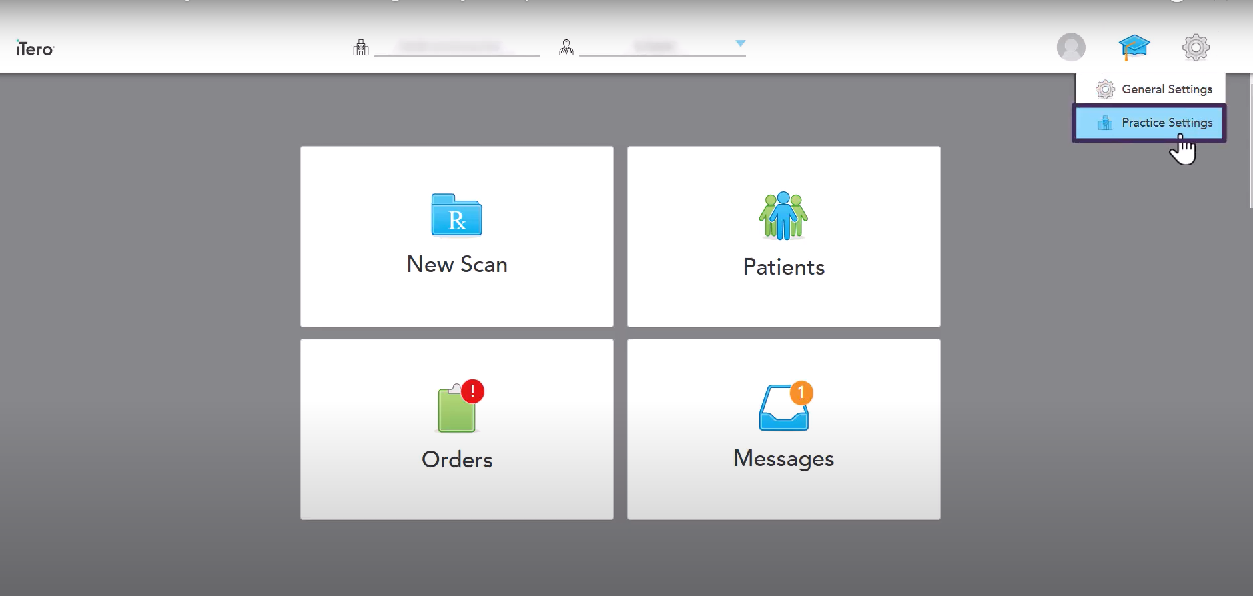
- In the Settings page, click My Labs.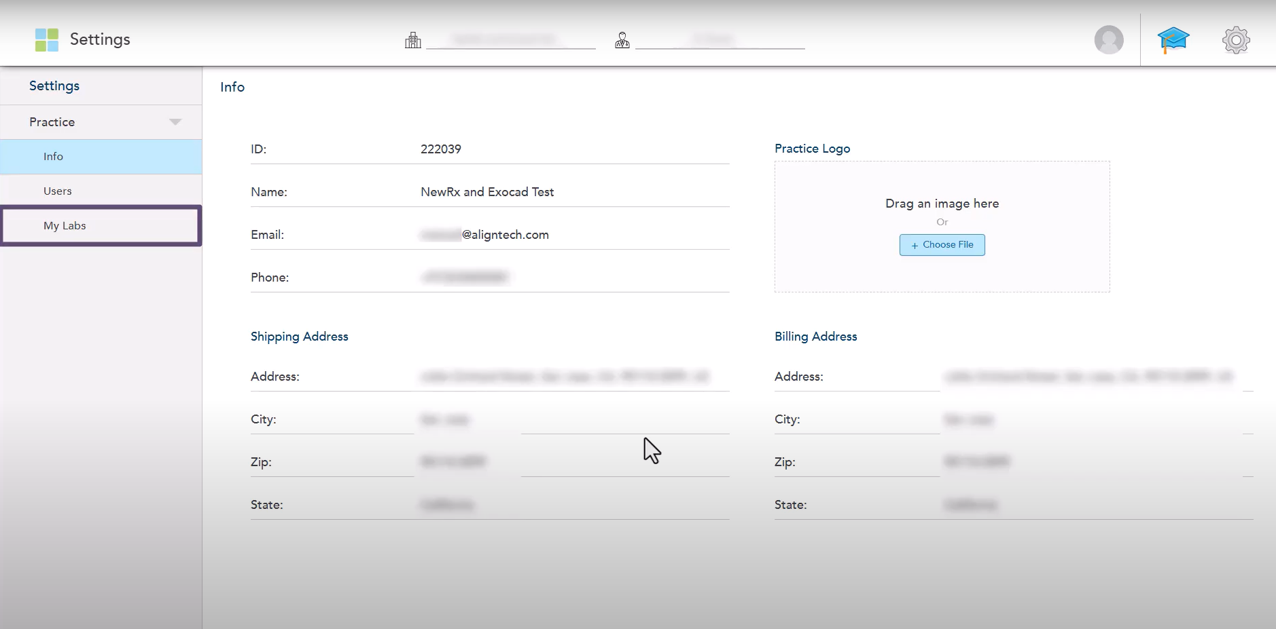
- All labs currently connected with your clinic will be listed here.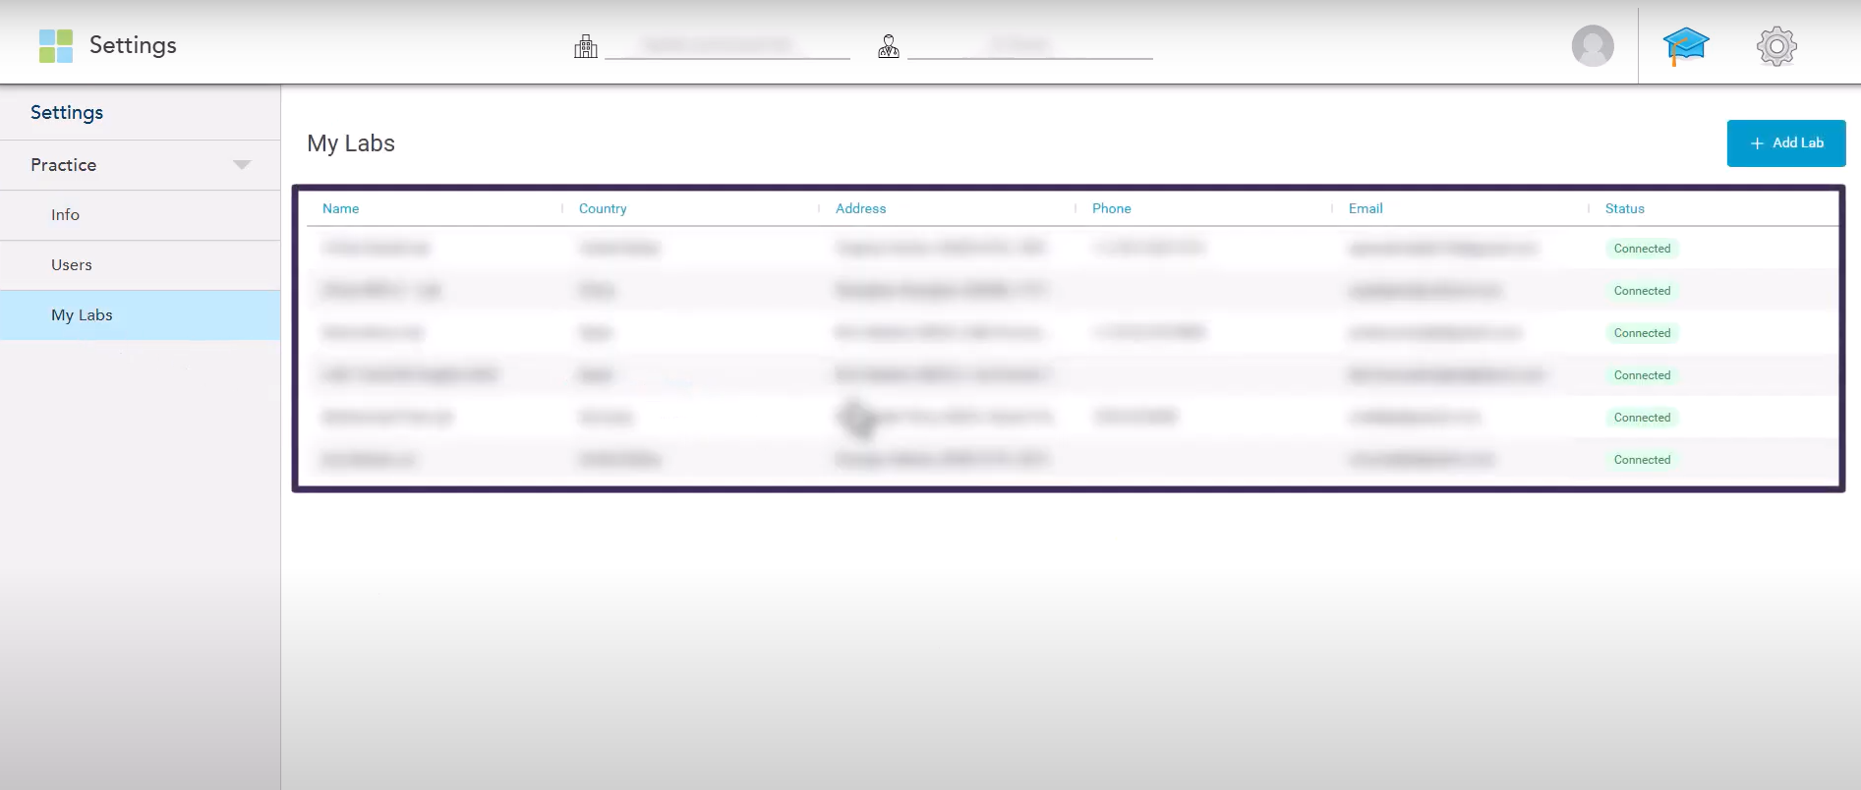
- To add a new lab, click the Add Lab button.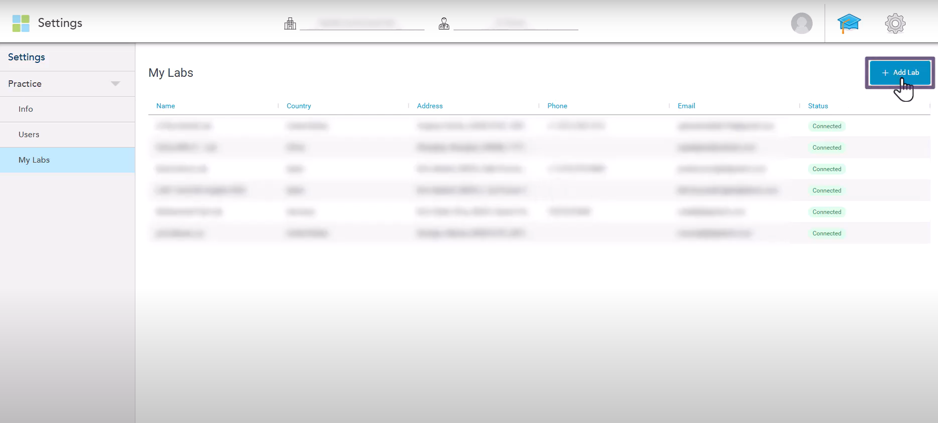
- In the search field, enter our lab’s name “Odontex”, then click Search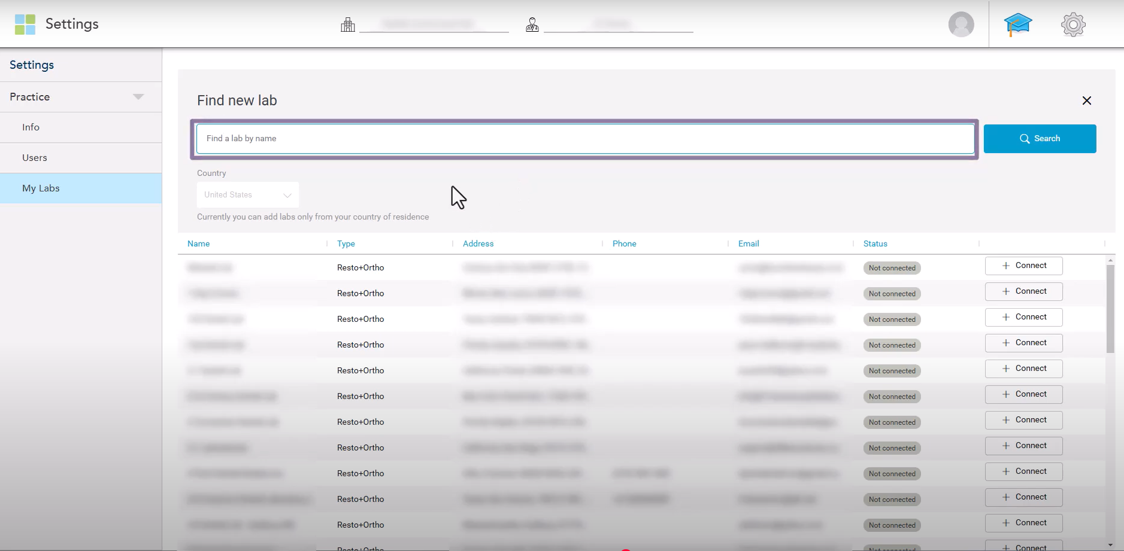
- The system will display all labs matching your search criteria. Locate Odontex and click Connect.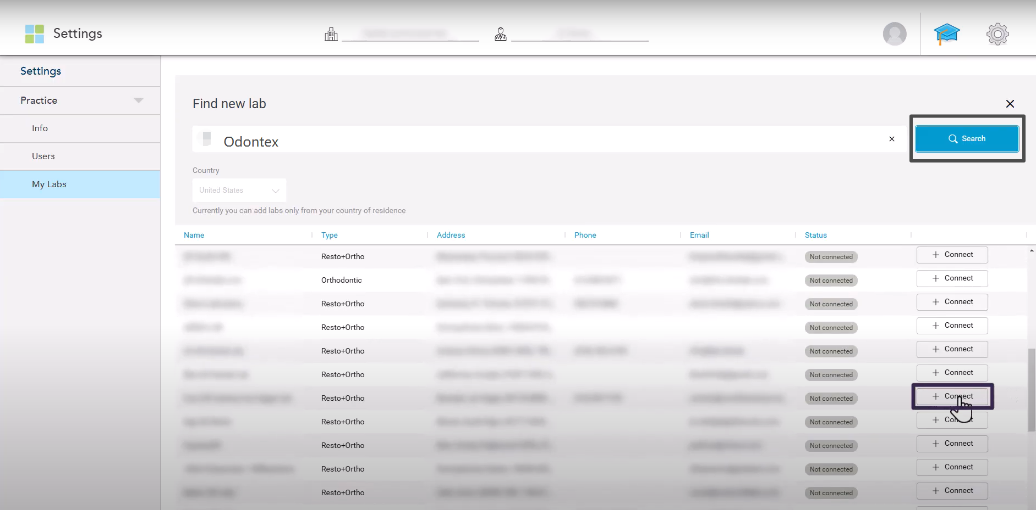
- A confirmation message will appear — click Yes to confirm the connection.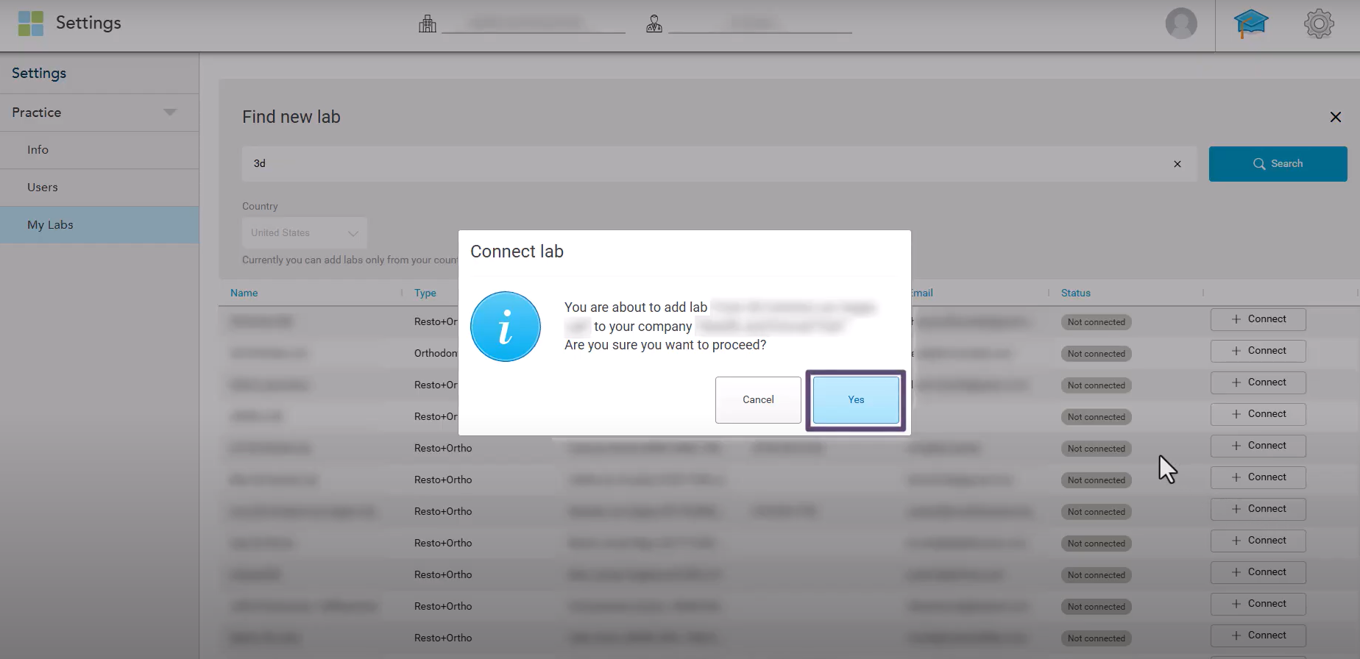
- Our lab will receive an email notification about your connection request.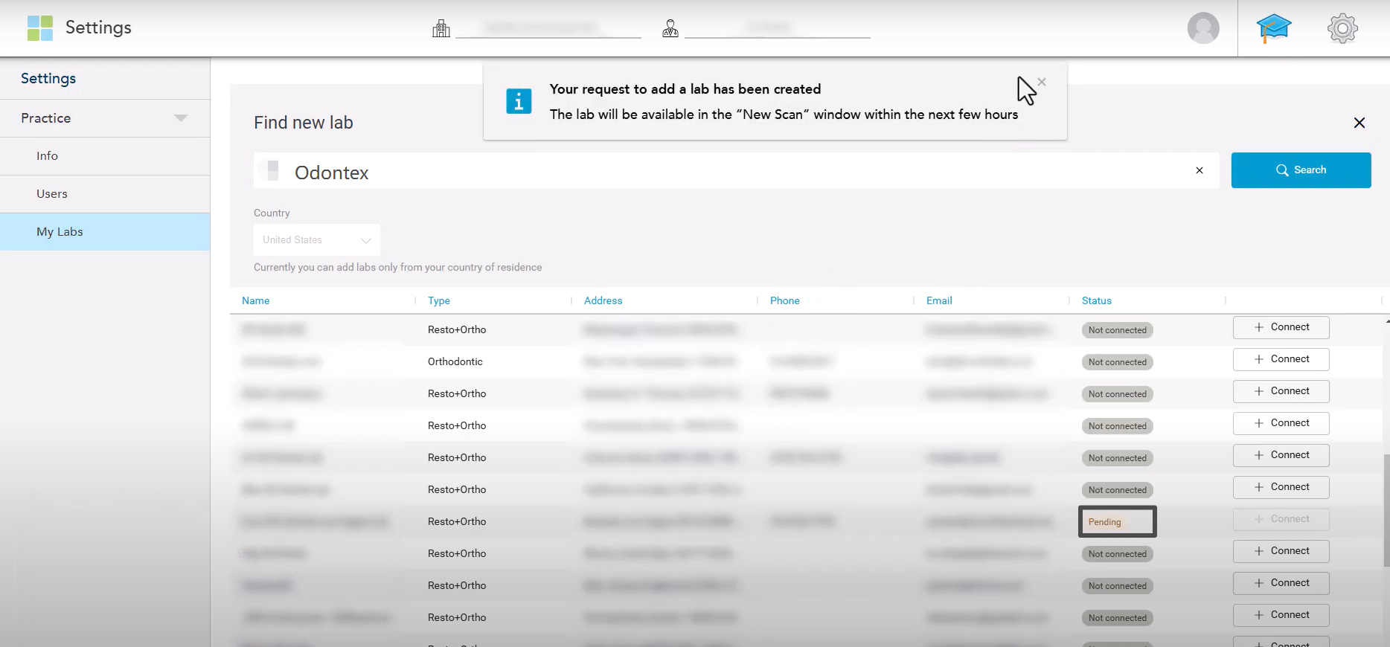
- The newly added lab will appear at the top of your lab list with a Pending status. Once we accept the request, it will change to Connected.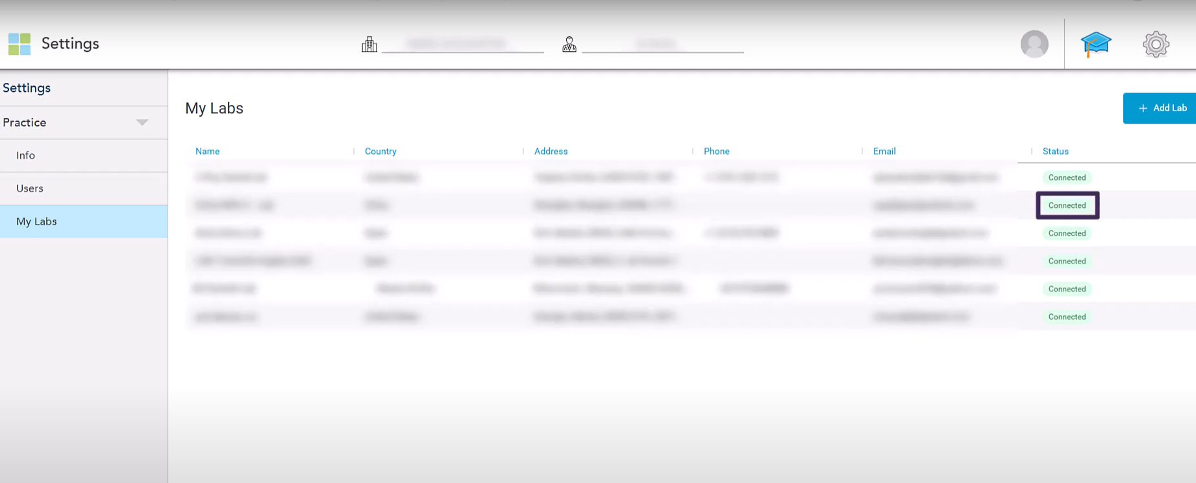
- After the connection is confirmed, Odontex will appear in your Send To list when completing your Rx.