Shining 3D Scanner
1: Log in to your shining 3D account. 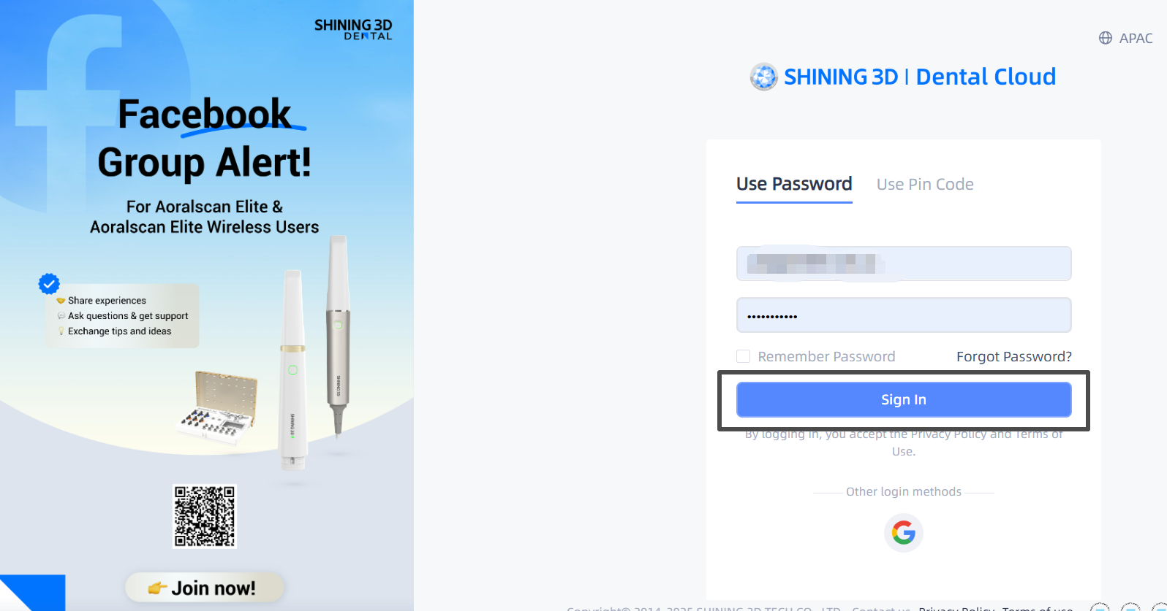
2: Click the “Connections” tab on the right-hand panel. 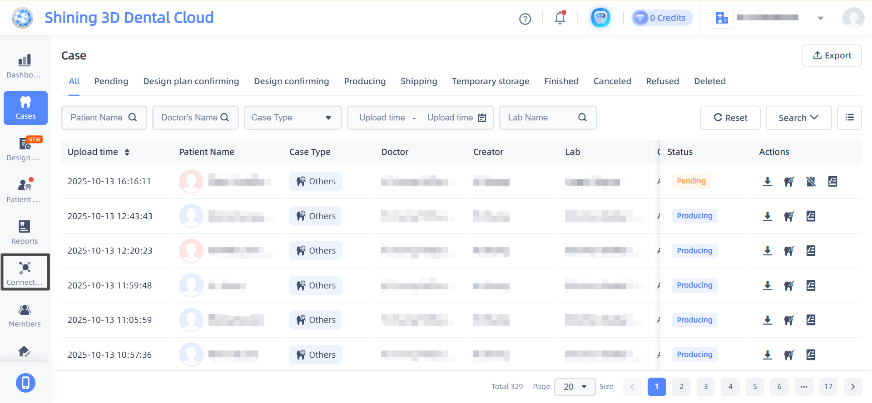
3: Click the “+ New” button in the window. 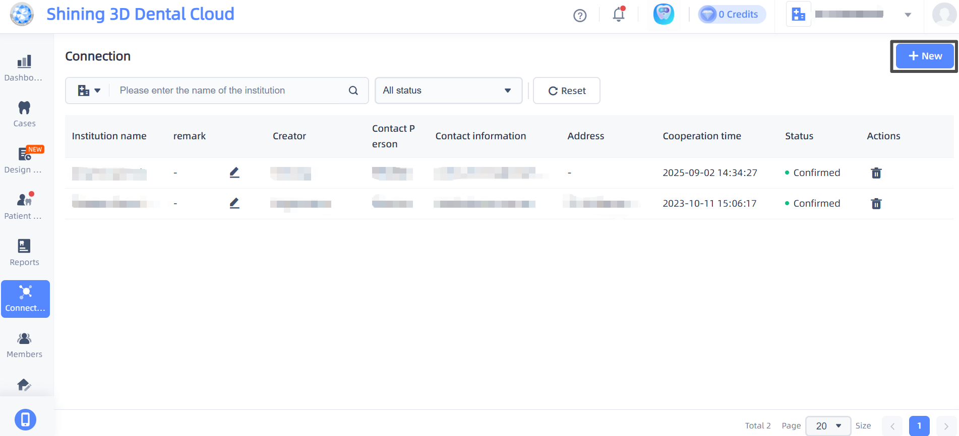
4: In the “Add Connections” window that pops up, enter our Lab name (Odontex). 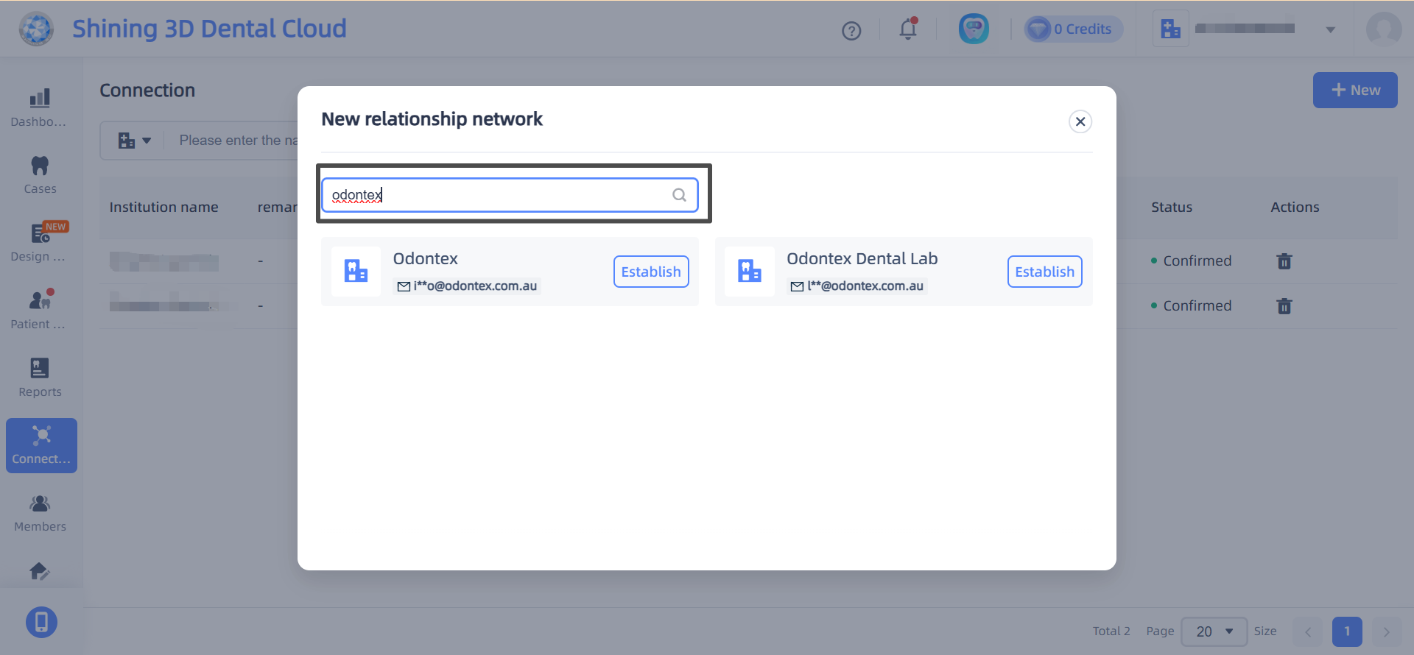
5: Click the tick button to submit the request. 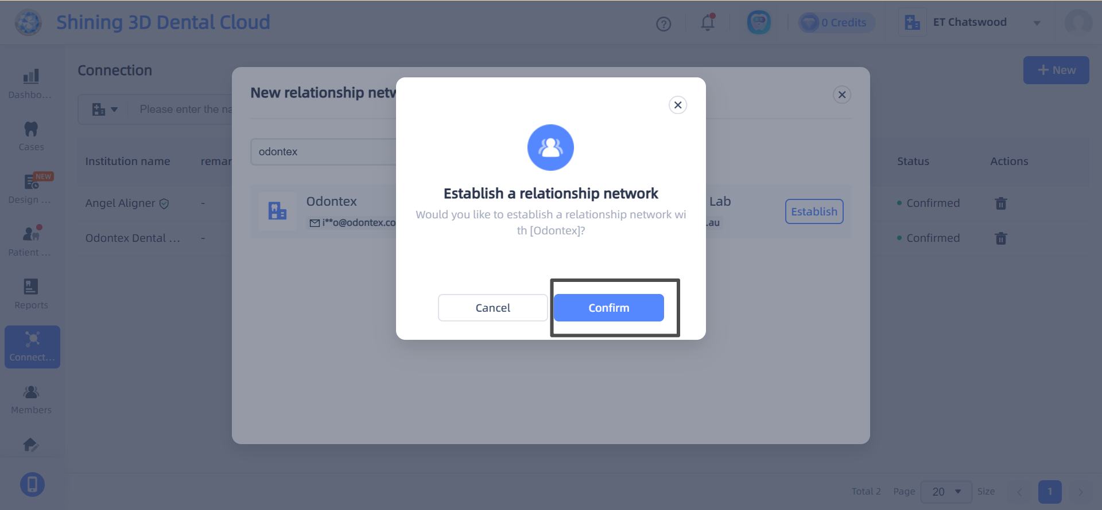
6: An approval request is automatically sent to our lab. Your connection status in the Add Connections window will be “Acceptance awaited” until we accept the request, then, it’ll change to “Confirmed.” 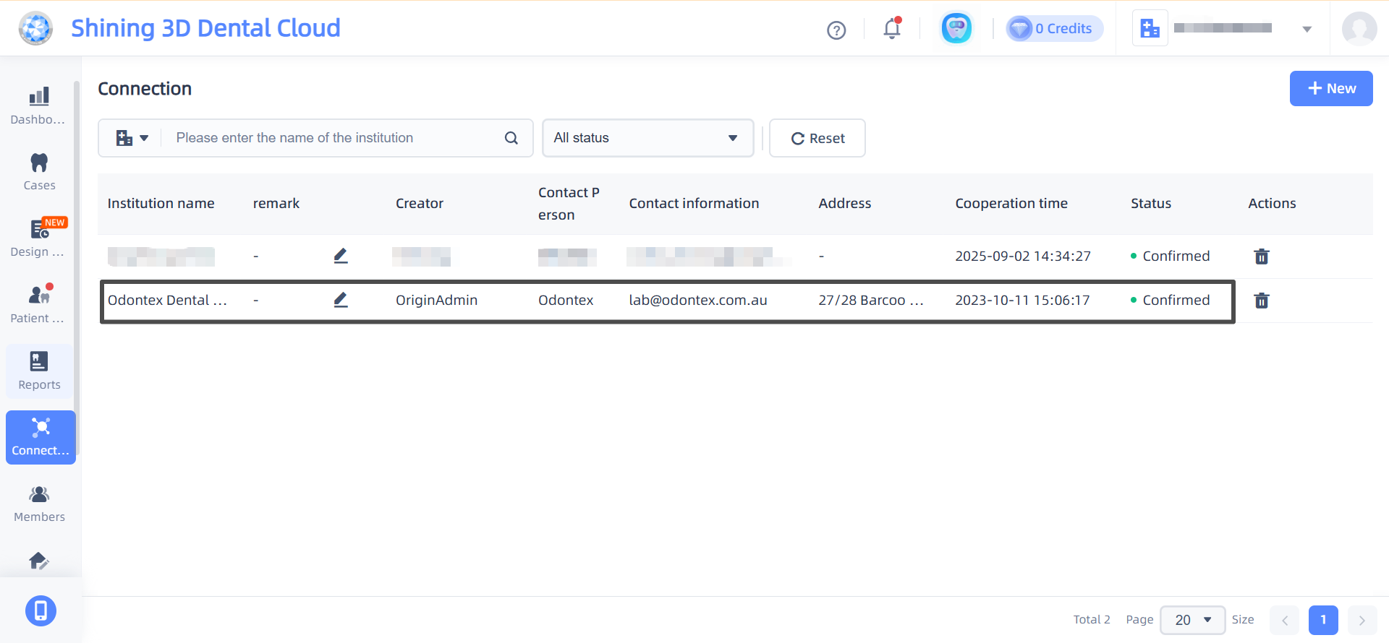
7: You can begin sending your cases to our lab.

