Medit Link
- Log in to your Medit Link account.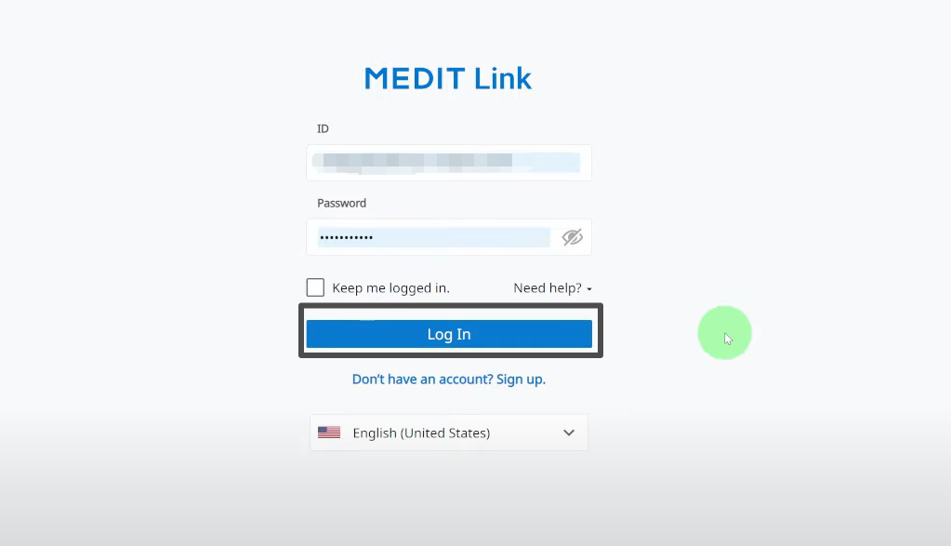
- From the left-hand menu, select Partners.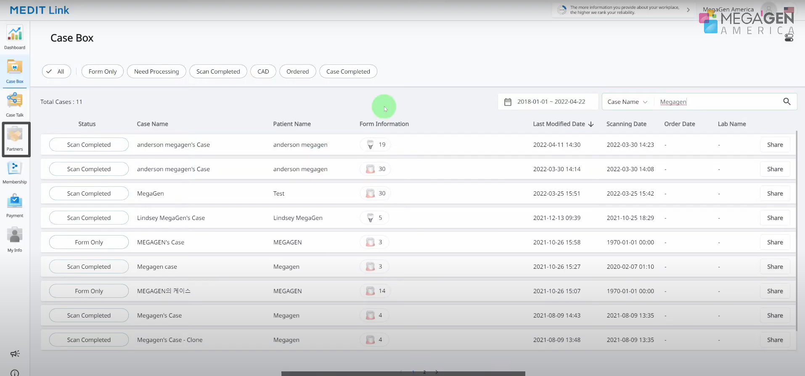
- In the search bar, enter our lab’s name “Odontex” and to search our lab.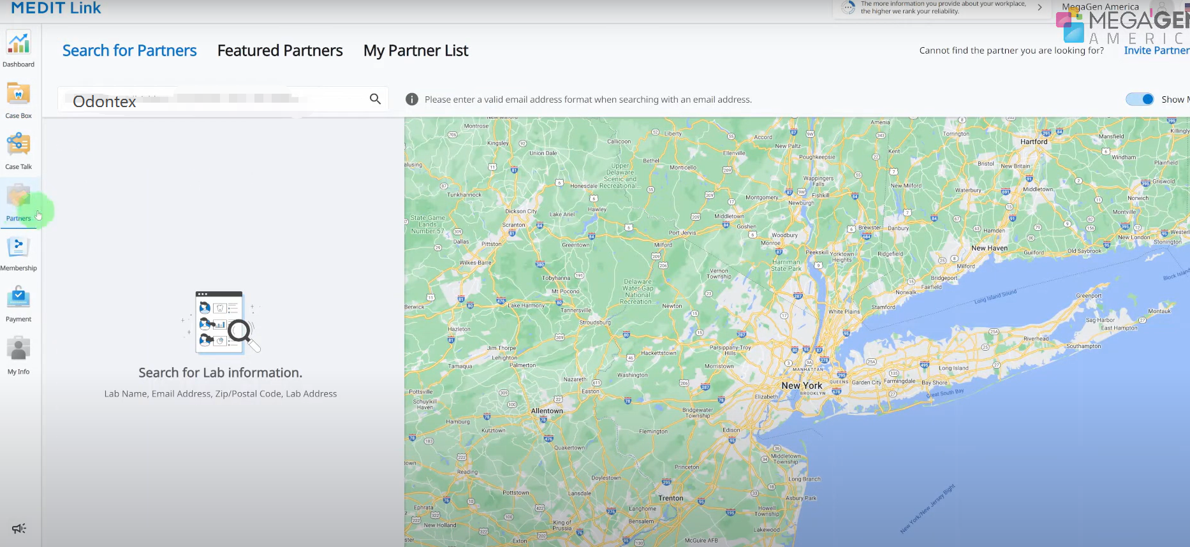
Find our lab in the results and click Request Partnership to send the request.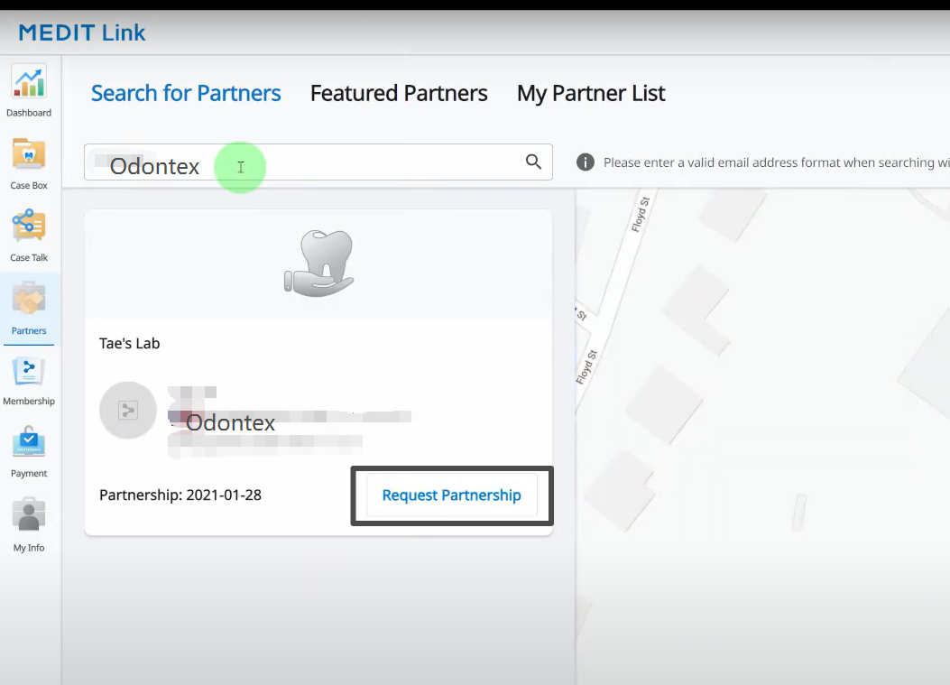

- Once we accept your partnership request, you can open the Medit Link program to place orders and send your completed cases directly to us.