DS Core
Step 1: Go to Your Practice Settings
- From your DS Core dashboard, click on your profile icon in the top-right corner.
- Select Practice from the dropdown menu. 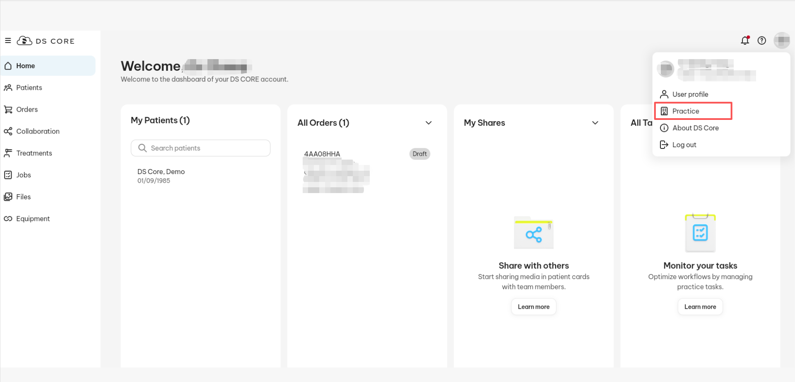
Step 2: Open the Preferred Labs Tab
- In the Practice section, click on the Preferred labs tab.
- Click the + Add preferred lab button on the right-hand side. 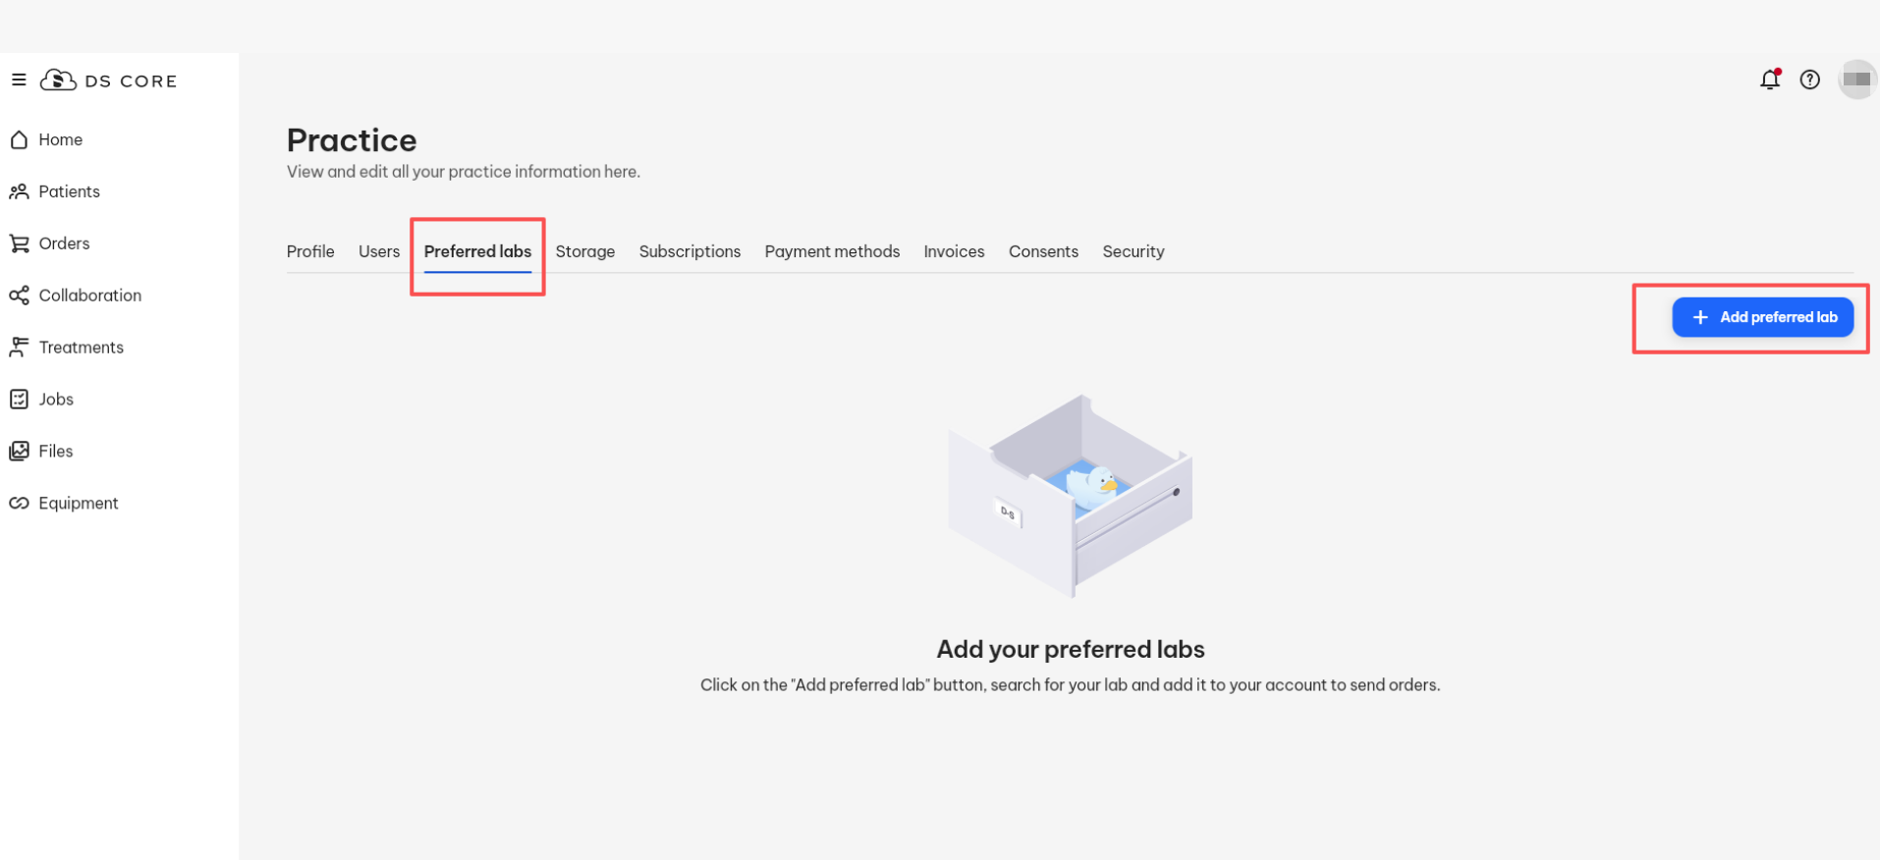
Step 3: Search for a Lab
- In the Add preferred lab window, use the search bar to type the name of the lab — for example, “Odontex.”
- The system will show a list of matching labs. 