3 Shape
- Login to your 3Shape Communicate account. If you don’t have one, click on ‘Create 3Shape Account’ and register for one.
- Open 3Shape Unite and go to ‘More’ and then click ‘Store’.
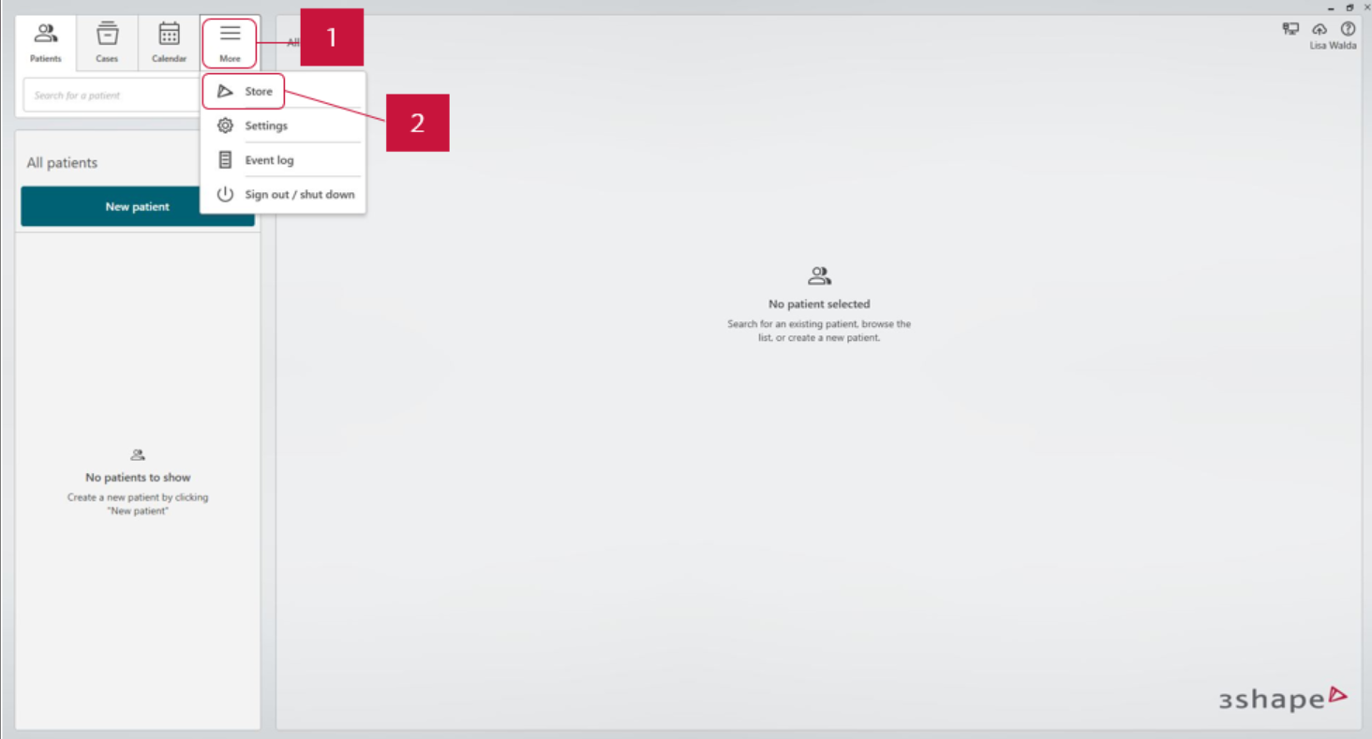
- Go to ‘Lab connections’, click ‘Add connection’ button and type in details of the lab you want to connect to*. You can search by name, address and email address and phone number. 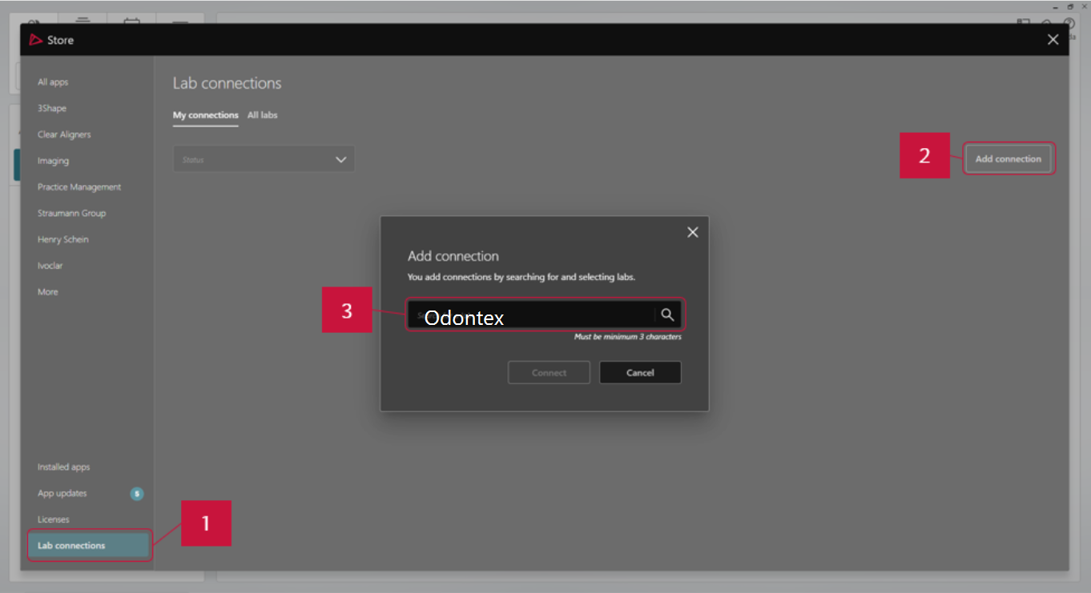
- Select ‘Odontex dental lab’ in the results. Click ‘Connect’. 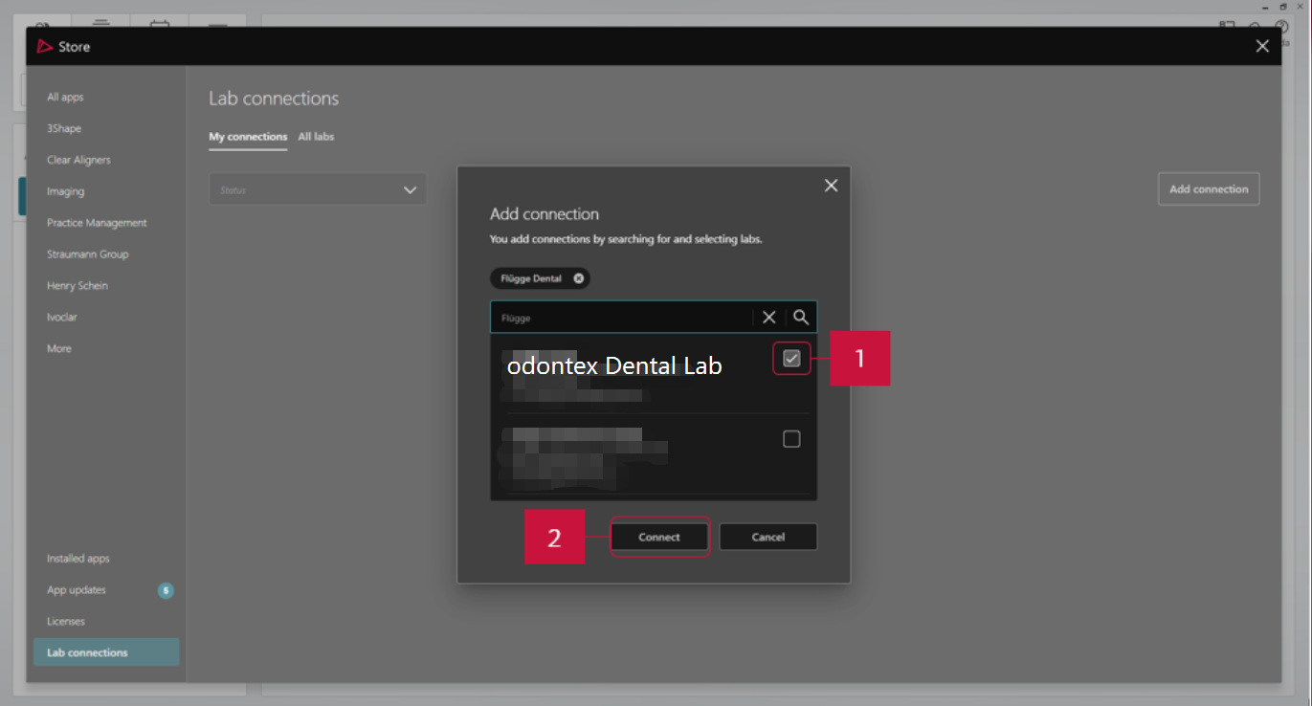
- Once we approve your connection request, the status of Southern Cross Dental will change from ‘Waiting for approval’ to ‘Active’.
- Go to your TRIOS® scanner, select ‘Configure’ > ‘Lab Connections’. Select ‘Communicate for External Connection’.
- Click ‘Refresh’. Make sure Odontex dental lab appears in your Communicate list.

